5E Lesson Plan Template
Teacher
Date | February 12th 2020
Subject area/course/grade level | Social Studies Grade-3
Materials | Natural disaster PowerPoints, Chromebooks, natural disaster worksheet, paper, pencil
Standards (State and ISTE Standards for Students) | State Standard  9 ) Identify ways to prepare for natural disasters  ISTE Standards  6)Creative Communicator-  - b. create original works or responsibly repurpose or remix digital resources into new creations  - d. publish or present content that customizes the message and medium for their intended audiences.  - 3)Knowledge Constructor  - 3a) Students plan and employ effective research strategies to locate information and other resources for their intellectual or creative pursuits.
Objectives | Students will learn about certain natural disasters and ways to prepare and survive if one occurs.  Students will use technology to find information about a natural disaster and create a fact and safety tip video about a natural disaster.
Differentiation Strategies (How will the lesson address the various learning styles of the students and the needs of those with special needs?) | Students who are visual learners will be able to see PowerPoint slides about natural disasters. Also will be able to understand natural disasters by looking at natural disaster simulators.  Reading and writing learners will be able to understand natural disasters by reading text from the internet and writing about what they read.  Special needs students will have shorten assignments and a peer helper to help assist with activities.

The 5 Es
E | Description | Assessment
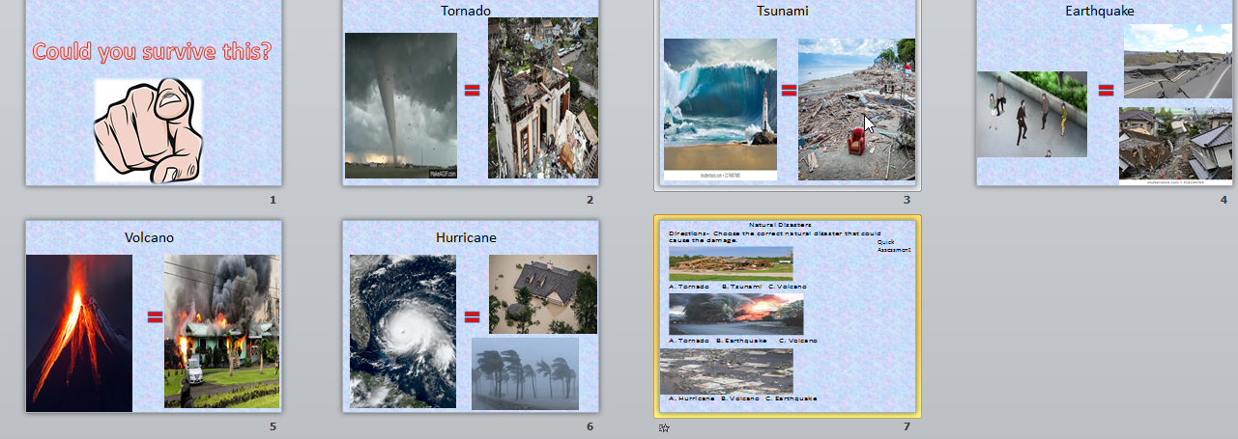  Engagement | The teacher will display the question on the board “Could you survive this?”  The teacher will then show a PowerPoint with pictures of 5 natural disasters and the damage they can cause. The natural disasters will be- a tornado, hurricane, tsunami, earthquake and volcano.  The teacher will ask “ Do you think you could survive this, how?”  The students will write their answer on their personal white boards.  The teacher will choose a few students to share their answers.  The teacher will ask if any students have survived any real life natural disaster.  The teacher will choose any student that would like to share.  PowerPoint screenshots below  .  Powerpoint screen shot | Match the disaster to the damage. The teacher will assess if students know the difference in tornado, tsunami, hurricane and volcano damage.  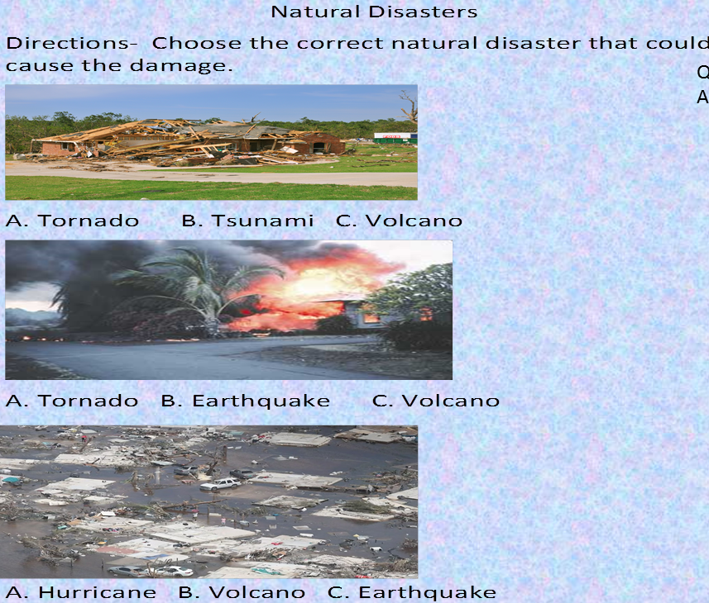
Exploration | Activity1-  Students will be in groups and rotate to simulator videos.  Each station has a simulation video about a natural disaster.  Before the video each student will predict what will happen on the video and share their predictions with the group.  The students will watch the video.  After the students watch the video they will write what actually happened in the video.  The students will share if their predictions were correct or anything that surprised them.  When the students are done with every station, they will meet as a whole group and share what they experienced.  Tornado simulator- https://www.youtube.com/watch?v=uZ3WRYcY4lo  Earthquake simulator-https://www.youtube.com/watch?v=6JBA8gP2jrU  Volcano simulator- https://www.youtube.com/watch?v=dY_3ggKg0Bc  Tsunami simulator- https://www.youtube.com/watch?v=KB-TO5kq5Aw  Flood simulator- https://www.youtube.com/watch?v=f_pFe3Jglvw  Activity 2-  The students will individually access the search engine Kiddle.co  The students will pick one natural disaster to research and write 3 facts about it and how to survive the natural disaster.  Activity 1, 2 worksheets photos are below.  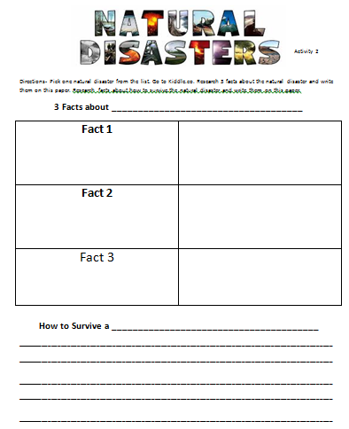  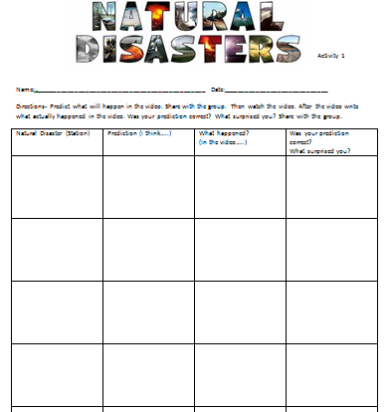 | Scenario sentences will be used to assess if students know the difference in experiencing a natural disaster.  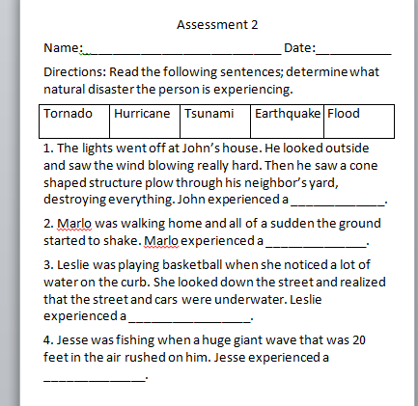
Explanation | Whole group-  The teacher will explain all 5 natural disasters separately.  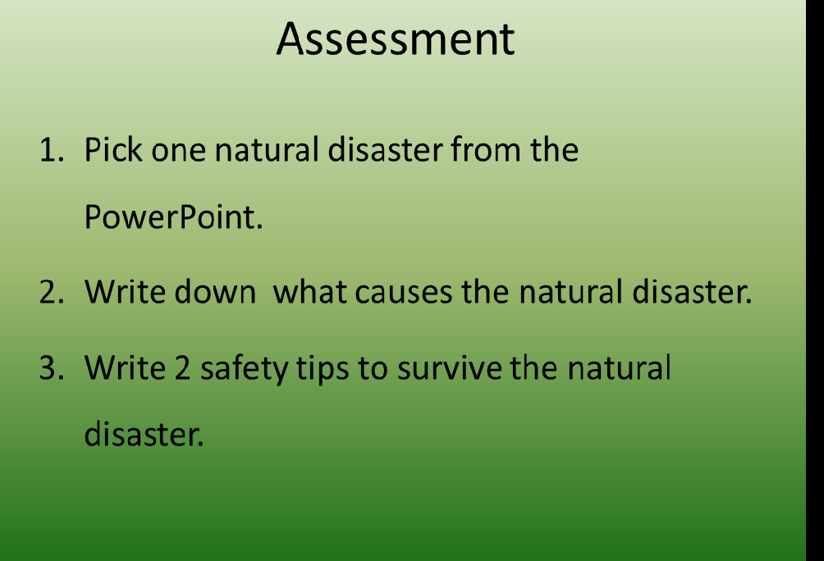  The teacher will have a PowerPoint slide for each disaster and talk about the dangers and survival tips to survive the disaster. After each slide the teacher will display the following questions for students to answer?  1. What causes the natural disaster?  2. Are there any warning signs before the natural disaster occurs? If so what is the sign(s)?  3. Why is it important to know the warning signs?  4. What should you do when the natural disaster occurs?  5. What affect does the natural disaster have on people and land?  The teacher will clear any misconceptions the students might have.  PowerPoint below  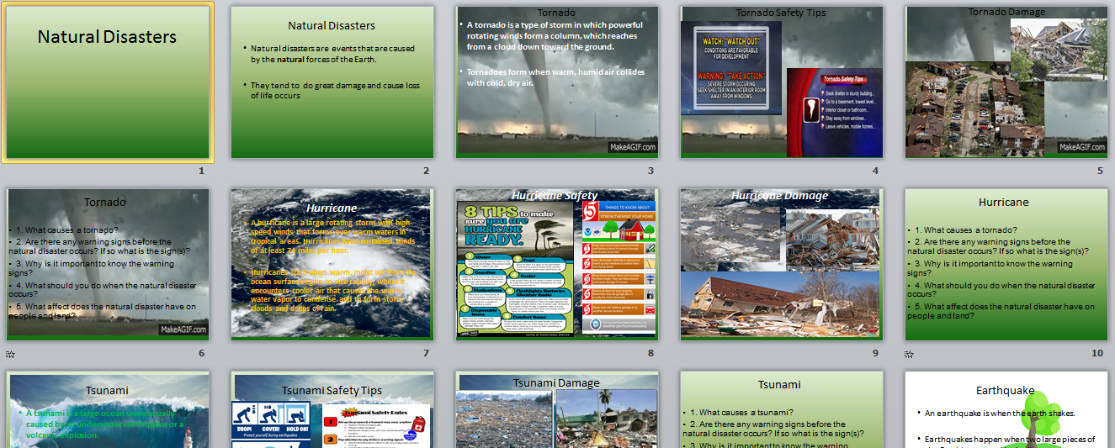  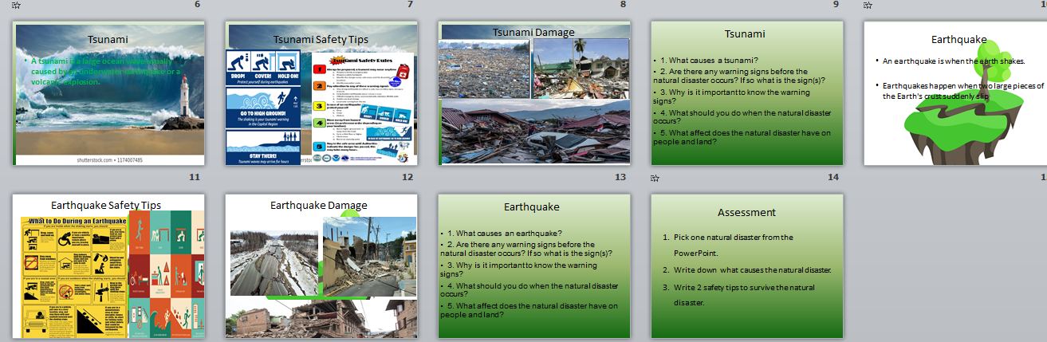 | The assessment will allow for the teacher to understand which student understands a certain natural disaster and if they know any safety tips.
Elaboration | The teacher will explain that the students are going to write an informative text about how to survive the natural disaster that they just researched.  The teacher will show students an example.  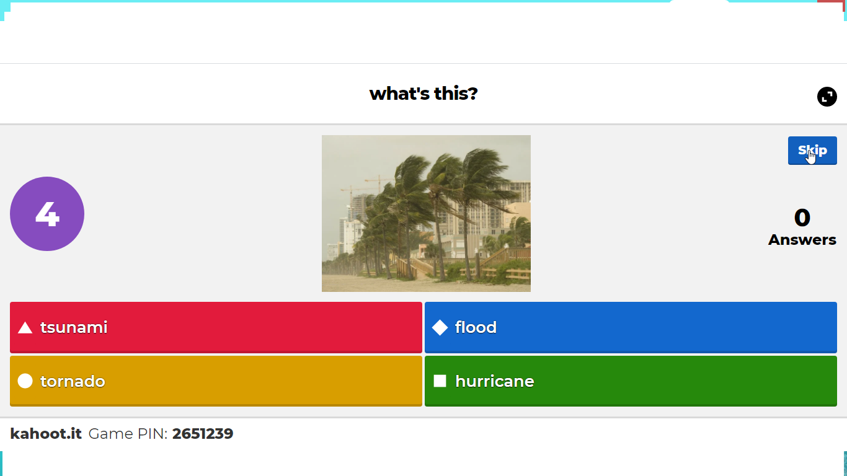  The students will write their text on a piece of paper.  The teacher will explain to the students that they will be using a new website called Blabberize to tell their information.  The teacher will explain that Blabberize is a website where people can take an image and make it talk by using their own voice. The teacher will show examples.  The teacher will explain to the students that they are going to create their own Blabberize with information about how to survive the natural disaster.  The teacher will walk the students through how to make a Blabberize.  When the teacher is done explaining, the students will log on to Blabberize and make their own about how to survive a natural disaster.  The teacher will assist with any technology needs.  Blabberize consist of videos, in order to access students’ created technology products go to https://blabberize.com/mystuff?m=m&p=1&l=9&sb=dmd  Or  Blabberize.com  then click my stuff or login  The username- sbriskey  Password-1234  Student work sample- http://blabberize.com/view/id/1920314  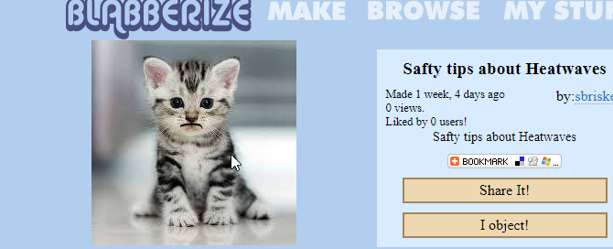 | The students will play a game of Kahoot as a formative assessment.  https://create.kahoot.it/details/natural-disasters/ed1bde3c-ba6f-4602-90fd-07ae3640b085  Students will be assessed on their Blabberize based on the criteria of the rubric.
Evaluation | The rubric was based on if students had the correct information about a certain natural disaster. Students could receive 60 points for having all the correct facts or safety tips.  The rubric also consisted of the ISTE standards.  Students were evaluated to see if they could use Kiddle.co to research facts and use Blabberize to create a video.  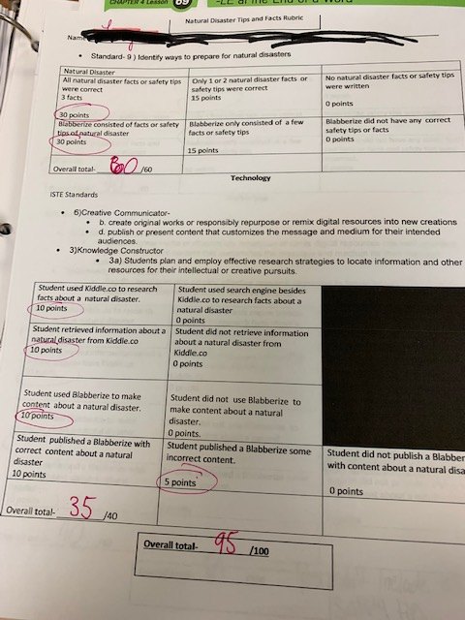  Student’s graded rubric-

